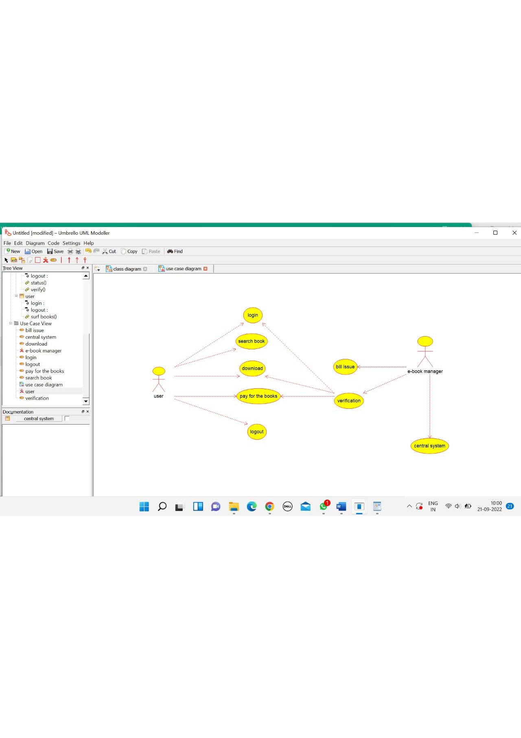

INTERNET

/**

* Class internet

*/

public class internet {

//

// Fields

//

private void enter_id;

private void download;

private void login;

private void logout;

//

// Constructors

//

public internet () { };

//

// Methods

//

//

// Accessor methods

//

/**

* Set the value of enter_id

* @param newVar the new value of enter_id

*/

private void setEnter_id (void newVar) {

enter_id = newVar;

}

/**

* Get the value of enter_id

* @return the value of enter_id

*/

private void getEnter_id () {

return enter_id;

}

/**

* Set the value of download

* @param newVar the new value of download

*/

private void setDownload (void newVar) {

download = newVar;

}

/**

* Get the value of download

* @return the value of download

*/

private void getDownload () {

return download;

}

/**

* Set the value of login

* @param newVar the new value of login

*/

private void setLogin (void newVar) {

login = newVar;

}

/**

* Get the value of login

* @return the value of login

*/

private void getLogin () {

return login;

}

/**

* Set the value of logout

* @param newVar the new value of logout

*/

private void setLogout (void newVar) {

logout = newVar;

}

/**

* Get the value of logout

* @return the value of logout

*/

private void getLogout () {

return logout;

}

//

// Other methods

//

/**

*/

public void verify()

{

}

/**

*/

public void status()

{

}

}

USER

/**

* Class user

*/

public class user {

//

// Fields

//

private void login;

private void logout;

//

// Constructors

//

public user () { };

//

// Methods

//

//

// Accessor methods

//

/**

* Set the value of login

* @param newVar the new value of login

*/

private void setLogin (void newVar) {

login = newVar;

}

/**

* Get the value of login

* @return the value of login

*/

private void getLogin () {

return login;

}

/**

* Set the value of logout

* @param newVar the new value of logout

*/

private void setLogout (void newVar) {

logout = newVar;

}

/**

* Get the value of logout

* @return the value of logout

*/

private void getLogout () {

return logout;

}

//

// Other methods

//

/**

*/

public void surf_books()

{

}

}

E-BOOK MANAGEMENT CLASS

/**

* Class e_book_management_class

*/

public class e_book_management_class {

//

// Fields

//

private void enter_id;

private void verify_user;

//

// Constructors

//

public e_book_management_class () { };

//

// Methods

//

//

// Accessor methods

//

/**

* Set the value of enter_id

* @param newVar the new value of enter_id

*/

private void setEnter_id (void newVar) {

enter_id = newVar;

}

/**

* Get the value of enter_id

* @return the value of enter_id

*/

private void getEnter_id () {

return enter_id;

}

/**

* Set the value of verify_user

* @param newVar the new value of verify_user

*/

private void setVerify_user (void newVar) {

verify_user = newVar;

}

/**

* Get the value of verify_user

* @return the value of verify_user

*/

private void getVerify_user () {

return verify_user;

}

//

// Other methods

//

/**

*/

public void check_availability()

{

}

}

